After sending Timothy and Erastus to Macedonia and the city of Corinth, Paul decided to stay in Ephesus for a little while longer. Before long, however, trouble arose in the city over his preaching of Jesus.

Acts 19:23-24 About that time there occurred no small disturbance concerning the Way. 24 For a man named Demetrius, a silversmith, who made silver shrines of Artemis, was bringing no little business to the craftsmen;

The main idol in Ephesus was the goddess Artemis, and the temple to this false god was one of the seven wonders of the world in that day. The temple measured 425 feet by 220 feet with 127 marble columns in the front. It was situated upon a hill overlooking the city and gave Ephesus its identity. Inside were many beautiful statues and idols and it was revered as a sacred place of worship by the pagans. The silversmiths of the area, made detailed silver miniatures of the temple and sold them to travelers who visited Ephesus so that they could worship Artemis/Diana at home. This very lucrative business – headed by a many named Demetrius – was being hurt by the preaching and teaching of Paul and the growing apostolic church in Ephesus.

Acts 19:25-26 these he gathered together with the workmen of similar trades, and said, "Men, you know that our prosperity depends upon this business. 26 "You see and hear that not only in Ephesus, but in almost all of Asia, this Paul has persuaded and turned away a considerable number of people, saying that gods made with hands are no gods at all.

This Demetrius called together the other silversmiths and began to speak against Paul, blaming their declining sales on Paul's preaching that a man-made god was not a god at all! Notice that his words were that Paul had “turned away a considerable number of people;” Paul's preaching was winning many idolatrous Ephesians to Jesus!

Acts 19:27-28 "Not only is there danger that this trade of ours fall into disrepute, but also that the temple of the great goddess Artemis be regarded as worthless and that she whom all of Asia and the world worship will even be dethroned from her magnificence." 28 When they heard this and were filled with rage, they began crying out, saying, "Great is Artemis of the Ephesians!"

The issue was not really that the men were such devoted worshippers of Artemis/Diana, but that their money-making venture was being hurt. How often, even today, men hide their greed behind religiosity! These men had not cared about Paul's preaching until it hurt their business! To protect their livelihood, the silversmiths began to passionately instigate an outcry against Paul and his teachings.

Acts 19:29-31 The city was filled with the confusion, and they rushed with one accord into the theater, dragging along Gaius and Aristarchus, Paul's traveling companions from Macedonia. 30 And when Paul wanted to go into the assembly, the disciples would not let him. 31 Also some of the Asiarchs who were friends of his sent to him and repeatedly urged him not to venture into the theater.

Provoking the crowd for their cause, the silversmiths took advantage of the confusion and grabbed some of Paul’s fellow ministers, Gaius and Aristarchus, and pulled them into a theatre for a public trial. The disciples and even some friends among the city leaders urged Paul not to go into the dangerous mob.

Acts 19:32-33 So then, some were shouting one thing and some another, for the assembly was in confusion and the majority did not know for what reason they had come together. 33 Some of the crowd concluded it was Alexander, since the Jews had put him forward; and having motioned with his hand, Alexander was intending to make a defense to the assembly.

Many of the crowd did not even realize what was going on but were just caught up in the moment of madness. The Jewish leaders decided that they did not want the Ephesians to confuse their religion with the Christians and – taking advantage of the situation – grabbed an eloquent speaker named Alexander and placed him before the crowd of people. Alexander was trying to show the Grecians that they did not support this "Jesus Christ" stuff.

Acts 19:34 But when they recognized that he was a Jew, a single outcry arose from them all as they shouted for about two hours, "Great is Artemis of the Ephesians!"

The crowd of Ephesians refused to listen to Alexander once they realized that he was a Jew, and in their mob-like passion spent the next two hours crying out "Great is Artemis of the Ephesians." What a tumult had been caused by one greedy silversmith!

Acts 19:35-36 After quieting the crowd, the town clerk said, "Men of Ephesus, what man is there after all who does not know that the city of the Ephesians is guardian of the temple of the great Artemis and of the image which fell down from heaven? 36 "So, since these are undeniable facts, you ought to keep calm and to do nothing rash.

The Grecian mayor of Ephesus finally quieted the people down until they would listen to him speak. He pointed out that everybody knew that the Ephesians worshipped Artemis/Diana and that it was impossible to ignore that fact. The term "fell down from heaven" refers to the Grecian myth that the original statue of Artemis/Diana in the temple had fallen from the "head god," Jupiter in ancient times.

Acts 19:37-38 "For you have brought these men here who are neither robbers of temples nor blasphemers of our goddess. 38 "So then, if Demetrius and the craftsmen who are with him have a complaint against any man, the courts are in session and proconsuls are available; let them bring charges against one another.

The mayor also pointed out that the Christians had done nothing unlawful or worthy of prosecution but the mob had broken the law by inciting a mob-type trial. If Demetrius and the silversmiths wanted to press criminal charges, then the courts were open and ready.

Acts 19:39-41 "But if you want anything beyond this, it shall be settled in the lawful assembly. 40 "For indeed we are in danger of being accused of a riot in connection with today's events, since there is no real cause for it, and in this connection we will be unable to account for this disorderly gathering." 41 After saying this he dismissed the assembly.

Pointing out that the city was already going to have to give reason for the riot to Rome, the levelheaded mayor began to calm down the crowd’s violent tendencies. Reason having gotten the upper hand, the crowd was dismissed and began to return home.

Acts 20:1 After the uproar had ceased, Paul sent for the disciples, and when he had exhorted them and taken his leave of them, he left to go to Macedonia.

After the uproar was over, Paul decided that it was time for him to leave Ephesus and continue west into Macedonia and visit the churches there.

Acts 20:2 When he had gone through those districts and had given them much exhortation, he came to Greece.

Paul visited once again the churches that he had established on his second missionary journey, traveling into Macedonia to the cities of Philippi, Thessalonica, and Berea before continuing on to Athens. We do not know many details about this time spent in Macedonia but we do know that Paul endured many trials and persecutions:

2 Cor 7:5-6 For even when we came into Macedonia our flesh had no rest, but we were afflicted on every side: conflicts without, fears within. 6 But God, who comforts the depressed, comforted us by the coming of Titus;

Titus came to Paul from Corinth with positive news from the church: they had responded to Paul's letter and Timothy's ministry! While in Macedonia, Paul decided to write another letter to the church in Corinth and send it back with Titus. This letter in our New Testament is called the book of 2 Corinthians. Here is an overview of the book of 2 Corinthians:

- Paul explains his change of plans in his missionary travels (2 Corinthians chapter 1).
- Paul explains his philosophy of ministry and describes his many victories and trials (2 Corinthians 2- 7).
- Paul praises the Macedonian churches for their generosity in participating in the offering for the churches in Judea and urges the Corinth church to give generously (2 Corinthians 8-9).
- Paul defends himself against accusations from his enemies that he is a coward, fleshly minded, and personally weak (2 Corinthians 10).
- Paul defends his Apostleship, ministry, and calling to the Gentiles (2 Corinthians 11-12).
- Paul asks the church to prepare themselves for his third visit to Corinth (2 Corinthians 13).

Paul then traveled into Greece and spent three months in Athens and Corinth, teaching and encouraging those churches. There is no scriptural record of the specific events of these months but undoubtedly Paul continued addressing the issues mentioned in I and II Corinthians.

While he was in Corinth, Paul's thoughts were focused upon Rome and the possibility of visiting there. Paul decided to write a letter to the churches in Rome and inform them of his desire to visit them. This letter is called the book of Romans and is one of the grandest theological works ever written. It was written to mature Christians who had been serving God for quite some time. Here is a brief overview of the book of Romans:

- All men, both Jews and Gentiles, are sinners and in need of God's Righteousness (Romans chapters 1-3).
- Paul describes God's righteousness and contrasts it with sin's condemnation (Romans 3-5).
- Paul describes how God's righteousness works in our life and how it corresponds with sin, the Mosaic law, and the Spirit of God (Romans 6-8).
- Paul describes the role of Israel in the past plan of God (Romans 9).
- Paul describes the role of Israel in the present plan of God (Romans 10).
- Paul describes the role of Israel in the future plan of God (Romans 11).
- Paul teaches how that the righteousness of God is demonstrated in a Christians actions toward God, society, government, and neighbors (Romans 12-13).
- Paul teaches the proper attitude of righteousness in Christian living and liberties (Romans 14-15).
- Paul discusses his future plans for missionary trips and his desire to visit Rome (Romans 15-16).

Acts 20:3 And there he spent three months, and when a plot was formed against him by the Jews as he was about to set sail for Syria, he decided to return through Macedonia.

After the three months spent in the Grecian cities of Athens and Corinth, Paul decided to travel back to Jerusalem and personally deliver the offering to the churches there. Paul originally desired to travel by ship directly back to Antioch but when he learned that the Jewish leaders were watching the sea ports to arrest him, Paul decided to return back through Macedonia on land.

Acts 20:4-5 And he was accompanied by Sopater of Berea, the son of Pyrrhus, and by Aristarchus and Secundus of the Thessalonians, and Gaius of Derbe, and Timothy, and Tychicus and Trophimus of Asia. 5 But these had gone on ahead and were waiting for us at Troas.

Paul traveled back through Berea, Thessalonica, and Philippi, and then many ministers joined him in Troas. Sopater is also referred to as Sosipater and was a Jewish Christian kin to Paul. Aristarchus and Secundus were from Thessalonica, and Aristarchus later traveled to Rome with Paul and was also cast into prison with him; of Secundus, we only know that he was one of those personally won to God by Paul in his first visit to Corinth and also in whose house Paul lodged while there. Forty-six years later the Apostle John would write a letter to Gaius which is the book of 3 John in our New Testament. As we have already discussed Timothy at great length, he needs no introduction here . Tychicus and Trophimus were from Ephesus and Tychicus would become one of the closest friends that Paul had. Trophimus accompanied Paul on several portions of his missionary journeys. Also notice the change in verse 5 from "they" to "us," indicating that the writer, Luke, had also joined the journey in Troas.

Acts 20:6 We sailed from Philippi after the days of Unleavened Bread, and came to them at Troas within five days; and there we stayed seven days.

Paul, Luke, and probably Sopater traveled together from Philippi to Troas and met the group mentioned above. They stayed in Troas for one week.

Acts 20:7-8 On the first day of the week, when we were gathered together to break bread, Paul began talking to them, intending to leave the next day, and he prolonged his message until midnight. 8 There were many lamps in the upper room where we were gathered together.

The night before they departed from Troas, Paul called all of the believers together and began to preach to them. Knowing that this might be his last time to preach to some of these Christians, Paul spoke until midnight!

Acts 20:9 And there was a young man named Eutychus sitting on the window sill, sinking into a deep sleep; and as Paul kept on talking, he was overcome by sleep and fell down from the third floor and was picked up dead.

They were gathered together in an "upper room" of a three story house and there was a young man named Eutychus who sat in the window ledge listening to Paul's long sermon. After a while Eutychus fell asleep during the message and fell from the window three stories to his death!

Acts 20:10-12 But Paul went down and fell upon him, and after embracing him, he said, " Do not be troubled, for his life is in him." 11 When he had gone back up and had broken the bread and eaten, he talked with them a long while until daybreak, and then left. 12 They took away the boy alive, and were greatly comforted.

Paul paused his preaching long enough to go down to the body of the young man, raised him back to life, and then continued his preaching until the morning came! After they had taken communion, the missionary party departed for the docks.

Acts 20:13 But we, going ahead to the ship, set sail for Assos, intending from there to take Paul on board; for so he had arranged it, intending himself to go by land.

For some reason Paul decided to walk to Assos while the other men sailed there. It was a faster journey to walk than to sail from Troas to Assos and the scripture do not tell us why the others sailed. Perhaps one of them was sick or older and unable to complete the journey on foot.

Acts 20:14-15 And when he met us at Assos, we took him on board and came to Mitylene. 15 Sailing from there, we arrived the following day opposite Chios; and the next day we crossed over to Samos; and the day following we came to Miletus.

Paul did join the ship at Assos and the group sailed south to Mitylene and then on to the island of Samos. After staying a few days, the missionary group sailed to Miletus which was a port city south of Ephesus.

Acts 20:16 For Paul had decided to sail past Ephesus so that he would not have to spend time in Asia; for he was hurrying to be in Jerusalem, if possible, on the day of Pentecost.

Paul had bypassed Ephesus on purpose for the sake of time. He wanted to be in Jerusalem by the day of Pentecost. Travel in those days was much slower than it is today and a ship was more likely to be delayed than to be on time. It is very probable that Paul was believing that God would do a mighty work at the feast among the Jewish people from all over the world that would be traveling there for the festival.

Acts 20:17-18 From Miletus he sent to Ephesus and called to him the elders of the church. 18 And when they had come to him, he said to them, "You yourselves know, from the first day that I set foot in Asia, how I was with you the whole time,

From Miletus, Paul sent word for the ministers of Ephesus to come and meet with him. When they came, he began to exhort them and remind them of the three years that he had spent there and all of his teachings.

Acts 20:19-20 serving the Lord with all humility and with tears and with trials which came upon me through the plots of the Jews; 20 how I did not shrink from declaring to you anything that was profitable, and teaching you publicly and from house to house,

Paul had taught the Ephesians thoroughly while there and had also endured many trials in Ephesus.

Acts 20:21-22 solemnly testifying to both Jews and Greeks of repentance toward God and faith in our Lord Jesus Christ. 22 "And now, behold, bound by the Spirit, I am on my way to Jerusalem, not knowing what will happen to me there,

Notice that Paul said that he is "bound by the spirit" to go to Jerusalem. Paul was returning to Judea because he felt like that the Spirit of God was directing him to go.

Acts 20:23-24 except that the Holy Spirit solemnly testifies to me in every city, saying that bonds and afflictions await me. 24 "But I do not consider my life of any account as dear to myself, so that I may finish my course and the ministry which I received from the Lord Jesus, to testify solemnly of the gospel of the grace of God.

Paul was not sure what would come about in Jerusalem but seemed to know that something drastic was going to happen. Despite having a foreboding about what was to come, Paul still trusted God completely!

Acts 20:25-27 "And now, behold, I know that all of you, among whom I went about preaching the kingdom, will no longer see my face. 26 "Therefore, I testify to you this day that I am innocent of the blood of all men. 27 "For I did not shrink from declaring to you the whole purpose of God.

God had revealed to Paul that this would be the last time that the church in Ephesus would ever see him; Paul had thus called for the leaders of the church so that he could bid them farewell and give them one last final charge!

Acts 20:28-29 "Be on guard for yourselves and for all the flock, among which the Holy Spirit has made you overseers, to shepherd the church of God which He purchased with His own blood. 29 "I know that after my departure savage wolves will come in among you, not sparing the flock;

Paul began to prophesy that false teachers would arise and begin to teach damnable doctrines and philosophies. He exhorted the ministers and pastors of Ephesus to guard the saints and protect them from these false teachings.

Acts 20:30-31 and from among your own selves men will arise, speaking perverse things, to draw away the disciples after them. 31 "Therefore be on the alert, remembering that night and day for a period of three years I did not cease to admonish each one with tears.

Paul even prophesied that there would be men in the church that would begin to teach false doctrines in order to draw men to them. We cannot base our doctrine on men's reputations or even spiritual experiences; all things must be founded in the complete, unadulterated Word of God! Verse 31 gives us some insight to what Paul was doing for the three years at Ephesus besides teaching in the Bible school: he had warned them of the dangers of false teaching and doctrines! Even today, false teaching is probably the most serious threat to the Apostolic church!

Acts 20:32-34 "And now I commend you to God and to the word of His grace, which is able to build you up and to give you the inheritance among all those who are sanctified. 33 " I have coveted no one's silver or gold or clothes. 34 "You yourselves know that these hands ministered to my own needs and to the men who were with me.

Paul realized that after all of his teaching he had to now leave the churches in the hands of God. Paul reminded the ministers that he had not asked for financial gain from them and had given everything to help them and establish them.

Acts 20:35-36 "In everything I showed you that by working hard in this manner you must help the weak and remember the words of the Lord Jesus, that He Himself said, 'It is more blessed to give than to receive.'" 36 When he had said these things, he knelt down and prayed with them all.
Paul had done this as an example to the ministers of Ephesus that they might be willing to give of their lives and abilities freely for the edification of the saints. After Paul had completed his charge and warning, he knelt and prayed together with the ministers of Ephesus.

Acts 20:37-38 And they began to weep aloud and embraced Paul, and repeatedly kissed him, 38 grieving especially over the word which he had spoken, that they would not see his face again. And they were accompanying him to the ship.

Realizing that this would be the last time that they would ever see him, the elders of Ephesus were quite emotional when they said goodbye. History teaches us that later, false doctrines did begin to creep into the church. Of all the Gentile churches, though, the churches in Ephesus held to the Apostolic doctrine the longest. This was in part to the influence of Timothy in later becoming a pastor of the church and the Apostle John choosing to make his home there. The main reason that the church in Ephesus held to the true doctrines of Christ was because of a group of determined leaders who were forever impacted by the warning and charge given here in Paul's farewell speech.

Acts 21:1-2 When we had parted from them and had set sail, we ran a straight course to Cos and the next day to Rhodes and from there to Patara; 2 and having found a ship crossing over to Phoenicia, we went aboard and set sail.

Paul and his missionary companions sailed through various islands and then continued on east to the city of Patara. There they found a direct ship to Phoenicia which was just outside of Galilee and sailed back to Judea.

Paul's third missionary journey was an important time in the early church's history for many reasons. First, Paul was able to revisit and further strengthen the churches that were now well established in Asia and Greece. Second, the mighty speaker Apollos was converted and brought into the churches. Third, Paul was able to establish a strong church in the important city of Ephesus which would become the center for world evangelism in the next generation. Fourth, Paul realized the power in writing letters to churches and began to write more profusely. The book of I Corinthians contains many doctrines and teachings that are not explained in detail anywhere else in scripture. The book of Romans presents basic theological concepts such as our sinful nature, walking after the Spirit, justification, Christ's work at Calvary, and Israel's role in the plan of God more clearly than any other New Testament book. Fifth, the Gospels of Matthew, Mark, and Luke were written at this time. Sixth, Paul's overwhelming desire to visit Rome and other countries became the driving force of his ministry during this time. As this missionary journey ends, the churches in Asia and Greece are the center of revival in the Christian world and are actually financially supporting the original churches in Jerusalem and Judea!
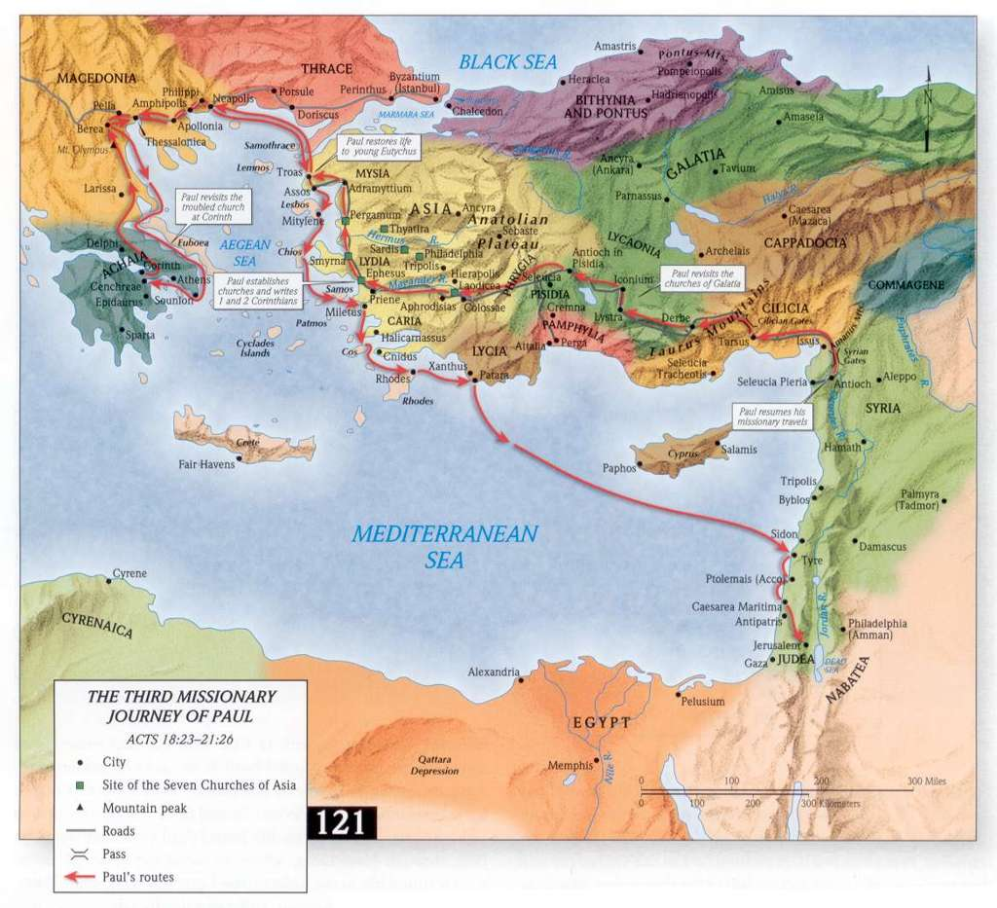

“Artemis” is more commonly known today as the goddess Diana, which is her name translated into Latin.
We know from 1 Timothy 1:20 and 2 Timothy 4:14 that Alexander had been one of the chief opponents to the Apostle Paul’s ministry in Ephesus.
We know this from 2 Corinthians 8:16-17.
See Romans 16:21.
See 1 Corinthians 1:14
See Romans 16:23.
Endnotes ? At this time there were many churches already established in Rome including one in the home of Priscilla and Aquilla who had moved back there (Romans 16:3-5) and another in the home of relatives of Paul, Adronicus and Junia, who had been a part of the apostolic church longer than Paul himself (Romans 16:7)! In Romans chapter 16, Paul sends personal greetings to over 27 people in the churches of Rome. The church in Rome had been established by converts from Asia moving there and beginning works for God and it is no wonder that Paul desired to visit Rome so badly.
Even today, the role of the pastor and the minister is to guard against false doctrines that will sow lies and confusion in the saints. From the garden of Eden until now, the devil has always worked through deceit and subtle variances from the true Word of God. That is why study of scripture is so important to make sure exactly what God has said!

